**TRƯỜNG THCS PHAN CÔNG HỚN**

**TỔ TIẾNG ANH**

**TIẾNG ANH 7**

**TUẦN 31 (TỪ 14/04 ĐẾN 19/04)**

**PHIẾU TỰ HỌC**

**Period 91: Unit 9 – Lesson 3-1 (Listening and Reading)**

**Period 92: Unit 9 – Lesson 3-2 (Writing and Speaking)**

**Period 93: Unit 9 – Review**

**Listening (SGK trang 74)**

1. 2
2. 1, 4, 6

**Reading (SGK trang 74)**

**a.** Canada

**b.** 1. True 2. False 3. True 4. True 5. False

**Writing (SGK trang 75)**

1. 5. Wish you were here!

3. Last Thursday, I went shopping in SoHo and oedered lunch ata café. I met an interesting guy from Peru. Wespoke English together.

4. Tomorrow, I’m walking around Central Park with him.

2. I’m having a great time in New York. I’m practicing English every day.

1. Hi Qúy,

**Review Unit 9 ( SGK trang 108,109)**

**Listening (SGK trang 108)**

1. B 1. A 2. C 3. E 4. G 5. F

**Reading (SGK trang 108)**

1. A 1. B 2. A 3. C 4. B 5. B

**Vocabuary (SGK trang 109)**

1. photos
2. flight
3. historic
4. wallet
5. stadium
6. souvenirs
7. tour guide
8. sightseeing

**Grammar (SGK trang 109)**

a.

1. the
2. the

b.

1. Did you visit the Empire State Building?

2. We took a flight to Boston the next day.

3. I bought lots of new clothes.

4. She didn’t have a swimsuit.

5. He lost his wallet.

6. They ate at a famous restaurant.

**Pronunciation (SGK trang 109)**

1. 1. A 2. B 3. D
2. 4. C 5. B 6. D

**SỬA BÀI TẬP TUẦN 30**

**UNIT 9: ENGLISH IN THE WORLD**

**LESSON 2-1 (New words)**

**II. Choose the word or phrase (A, B, C or D) that best fits the space in each sentence.**

1. Our trip to New Zealand was great! We took so many _________________.

A. **photos** B. wallets C. beaches D. holidays

2. We went to the airport very early because our _____________ departed at 6 a.m.

A. day B. tour C. **flight** D. sightseeing

3. There are many _________ buildings in Vienna. The oldest one is more than one thousand years old.

A. **historic** B. modern C. new D. cool

4. My brother forgot his _________________ so I had to pay for him.

A. postcard B. **wallet** C. photo D. flight

5. I like to buy ______when visiting different cities, but I never write on any of them.

A. **postcards** B. wallets C. photos D. flights

6. I like to decorate my room with the _________________ I bought from my trips. I have a doll from Japan, a small statue from Cambodia, and some paintings from Malaysia.

A. holidays B. tips C. **souvenirs** D. presents

7. Our _________________ was great. She was very friendly and helpful. She told us a lot about the history of the town.

A. volunteer B. **tour guide** C. traveler D. goer

8. We went _________________ and then spent a few days by the sea.

A. making B. doing C. cleaning D. **swimming**

9. John____ in Singapore at 5 pm yesterday

A. reached B. **arrived** C. departed D. got

10. At the age of 86, Barry traveled around the world_______ his sidecar.

A. at B. **on** C. from D. with

**---------------------------------------------------------**🙡🕮🙣**---------------------------------------------------------**

**UNIT 9: ENGLISH IN THE WORLD**

**LESSON 2-2 (Grammar)**

**II. Fill in the blanks with the Past Simple form of the verbs.**

1. We ____**saw**_________ the Sydney Opera House. (see)
2. I ______**took**_______ lots of photos of the castles. (take)
3. We _____**had**_________ many delicious Australian dishes. (have)
4. The weather ____**was**_________ cold so I wore a big jacket. (be)
5. We ___**didn’t go**________ go to the park because it was late when we got back. (not go)
6. My friend just _____**came**_______ back from New Zealand. (come)
7. _____**Did**_______you ____**eat**________ lots of tasty food in London? (eat)
8. I ______**bought**________ many souvenirs for my friends (buy)
9. We _______**didn’t visit**_______ Sapa last summer vacation. (not visit)
10. Last night we ___**went**_________ to Lan’s birthday. (go)
11. We ______**moved**____________ to this city ten years ago. (move)
12. My mother ________**bought**__________ me a dictionary last week. (buy)
13. My parents ______**visited**____________ my grandparents yesterday. (visit)

**III.** **Read the following passage. Decide if the statements from 1 to 4 are True or False and choosethe correct answer (A, B, C or D) for the questions 5 and 6.**

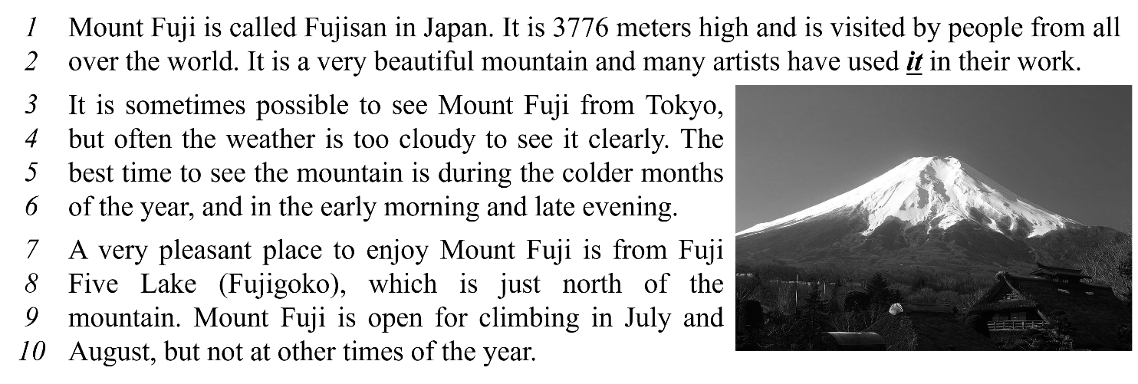 ***Write TRUE or FALSE.***

1. Mount Fuji is a high mountain. ___**True**_____

2. We can see Mount Fuji clearly every day. ___**False**_____

3. Fuji Five Lake is in the north of Mount Fuji. ___**True**_____

4. In December, we can go climbing in Mount Fuji. ___**False**_____

***Choose correct answer for each question.***

5. What does the word ***it*** in line 2 refer to?

A. the world B. **Mount Fuji** C. Japan D. artists

6. When is the best time to see Mount Fuji?

A. from Fuji Five Lake B. in August

C. in cold months D. **In Summer**

**---------------------------------------------------------**🙡🕮🙣**-------------------------------------------------------**

**UNIT 9: ENGLISH IN THE WORLD**

**LESSON 2-3 (Pronunciation)**

**I. Find the word whose underlined part differs from the other three in pronunciation.**

1. A. America B. summer **C. postcard** D. department
2. A. souvenir B. parliament **C. ferry** D. demon
3. A. weather **B.** **wallet** C. Australia D. hover
4. A. attraction B. decorate C. tradition **D. swimsuit**
5. **A. holiday** B. muddy C. sculpture D. subway

**II. Find the word that differs from the other three in the position of primary stress.**



1. A. cheesesteak B. stadium **C. historic** D. muddy
2. A. balloon B. participant C. exchange **D. roastery**
3. **A. defeat** B. temple C. national D. gallery
4. A. parliament B. comfortable C. negative **D. competition**
5. A. disappointed **B. experience** C. transportation D. volunteer

**III. Choose the word (A, B, C or D) that best fits the space in the following passage.**

Dear Ben,

I’m glad to hear about your trip. Last Sunday, students from my school also (11) ______ on an excursion. We visited Củ Chi tunnel. We came to school at 6:00 AM. Ten big buses (12) ______ us there. All of us (13) ______ excited, so we sang all the way to Củ Chi. We arrived there at 7:00 AM. A tourist guide showed us the historical places: the Củ Chi long tunnel and the kitchen under the ground where people cooked their meals. We made a tour around that place.

Then we went to Bến Dược temple we (14) ______ lots of names of the soldiers on the walls. We admired them very much. Our teacher asked us to write a report. We (15) ______ writing it now. We feel very happy to write what we’ve learned from that trip. We hope to come back to Củ Chi someday.

As I’ve mentioned, I have to finish my report, so I’ll stop now. Hope to hear from you soon.

Jerry

1. A. go B. goes **C. went** D. gone
2. **A. took** B. taked C. take D. taken
3. A. are **B. were** C. was D. is
4. A. see B. seed C. sed **D. saw**
5. A. are **B. were** C. was D. is

**IV. Rearrange the groups of words in a correct order to make complete sentences.**

1. souvenirs / Yesterday, / bought / I /.//  
   🡪Yesterday,**I bought souvenirs.**
2. We / delicious / Japanese dishes/ had / many /.//  
   🡪We **had many delicous Japanese dishes.**



1. new food/ try / you / Did / any /?//  
   🡪Did **you try any new food?**
2. Jimmy / wallet / forgot / his /.//  
   🡪Jimmy **forgot his wallet.**
3. didn’t visit/ because/ Buckingham Palace/ My mom/ late/ it was /.//  
   🡪My mom **didn’t visit Buckingham Palace because it was late.**